Project: MindGame
Members: Vineela Goli, Raj Laskar
CI Pipeline Checks Result:
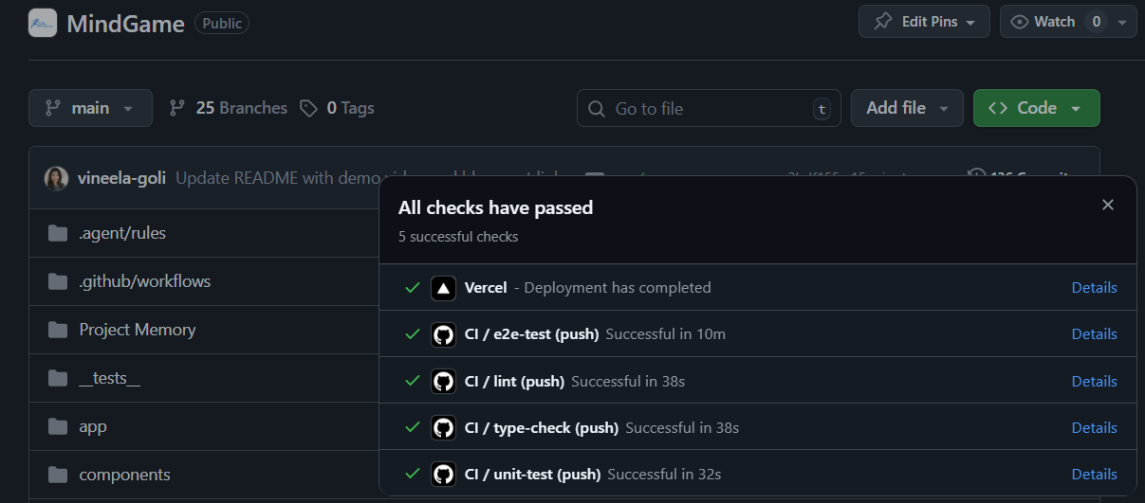
E2E Details:
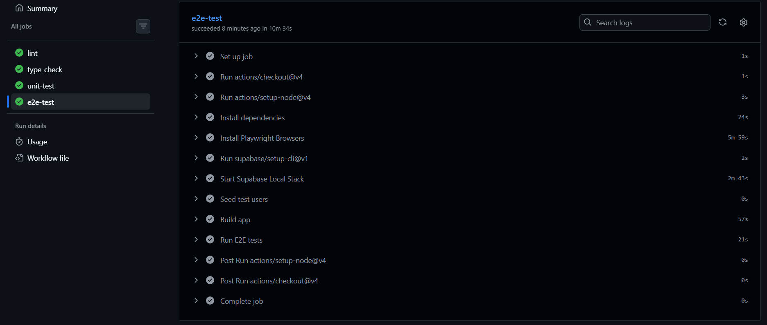
E2E Result Log:
Run npx playwright test
npx playwright test
shell: /usr/bin/bash -e {0}
env:
SUPABASE_INTERNAL_IMAGE_REGISTRY: ghcr.io
NEXT_PUBLIC_SUPABASE_URL: http://127.0.0.1:54321
NEXT_PUBLIC_SUPABASE_ANON_KEY: ***
SUPABASE_SERVICE_ROLE_KEY: ***
NEXT_PUBLIC_VAPID_PUBLIC_KEY:
VAPID_PRIVATE_KEY:
Running 5 tests using 1 worker
Starting coach signup...
Waiting for coach home redirect...
Coach home reached.
Navigating to template creation...
Adding technique from library...
Saving template...
Verifying template in list...
Sharing template...
Checking for "Sharing..." button state...
Waiting for toast...
Toast appeared!
Navigating to roster...
BROWSER CONSOLE: Failed to load resource: the server responded with a status of 400 (Bad Request)
[WebServer] Using the user object as returned from supabase.auth.getSession() or from some supabase.auth.onAuthStateChange() events could be insecure! This value comes directly from the storage medium (usually cookies on the server) and may not be authentic. Use supabase.auth.getUser() instead which authenticates the data by contacting the Supabase Auth server.
[WebServer] Using the user object as returned from supabase.auth.getSession() or from some supabase.auth.onAuthStateChange() events could be insecure! This value comes directly from the storage medium (usually cookies on the server) and may not be authentic. Use supabase.auth.getUser() instead which authenticates the data by contacting the Supabase Auth server.
[WebServer] Using the user object as returned from supabase.auth.getSession() or from some supabase.auth.onAuthStateChange() events could be insecure! This value comes directly from the storage medium (usually cookies on the server) and may not be authentic. Use supabase.auth.getUser() instead which authenticates the data by contacting the Supabase Auth server.
[WebServer] The width(-1) and height(-1) of chart should be greater than 0,
[WebServer] please check the style of container, or the props width(100%) and height(100%),
[WebServer] or add a minWidth(0) or minHeight(undefined) or use aspect(undefined) to control the
[WebServer] height and width.
[WebServer] Using the user object as returned from supabase.auth.getSession() or from some supabase.auth.onAuthStateChange() events could be insecure! This value comes directly from the storage medium (usually cookies on the server) and may not be authentic. Use supabase.auth.getUser() instead which authenticates the data by contacting the Supabase Auth server.
[WebServer] Using the user object as returned from supabase.auth.getSession() or from some supabase.auth.onAuthStateChange() events could be insecure! This value comes directly from the storage medium (usually cookies on the server) and may not be authentic. Use supabase.auth.getUser() instead which authenticates the data by contacting the Supabase Auth server.
[WebServer] Using the user object as returned from supabase.auth.getSession() or from some supabase.auth.onAuthStateChange() events could be insecure! This value comes directly from the storage medium (usually cookies on the server) and may not be authentic. Use supabase.auth.getUser() instead which authenticates the data by contacting the Supabase Auth server.
[WebServer] Using the user object as returned from supabase.auth.getSession() or from some supabase.auth.onAuthStateChange() events could be insecure! This value comes directly from the storage medium (usually cookies on the server) and may not be authentic. Use supabase.auth.getUser() instead which authenticates the data by contacting the Supabase Auth server.
[WebServer] Using the user object as returned from supabase.auth.getSession() or from some supabase.auth.onAuthStateChange() events could be insecure! This value comes directly from the storage medium (usually cookies on the server) and may not be authentic. Use supabase.auth.getUser() instead which authenticates the data by contacting the Supabase Auth server.
[WebServer] Using the user object as returned from supabase.auth.getSession() or from some supabase.auth.onAuthStateChange() events could be insecure! This value comes directly from the storage medium (usually cookies on the server) and may not be authentic. Use supabase.auth.getUser() instead which authenticates the data by contacting the Supabase Auth server.
·····
5 passed (19.1s)

